**Women Empowerment Index: Analysis on**

**NFHS of India**

**Summer Internship Programme**

**(2023-24)**

Ministry of Statistics & Programme Implementation

(MoSPI), GoI.

**Place of Internship:**

Biostatistics Section,

National Institute for Tuberculosis & Respiratory

Diseases (NITRD), New Delhi-110030.

Under the Guidance of

Ms. Ankita Dey

(Statistician, NITRD)

Submitted By

**Mr. Nischay Gautam**

Master of Statistics (2nd year), AIAS

Amity University Noida, Uttar Pradesh.

**Acknowledgement**

I would like to express my sincere gratitude and appreciation to copious people and organizations who helped this internship be completed successfully.

First and foremost, I would like to express my sincere gratitude to the Director, National Institute of Tuberculosis and Respiratory Diseases (NITRD), New Delhi, for giving me the opportunity to take up the academic internship programme at the Institute.

I want to express my sincere gratitude to Ms. Ankita Dey, Statistician, NITRD for her invaluable advice and technical assistance throughout my internship. Her guidance and recommendations have greatly improved and developed my domain knowledge in statistics , necessitating more in-depth understanding of the topic and efficient application of data analytical techniques in real world situations. I am incredibly appreciative of her ongoing assistance and guidance.

As part of their support for this internship, the Ministry of Statistics and Programme Implementation (MoSPI), GoI deserves recognition as well. I am appreciative of MOSPI's assistance in facilitating this worthwhile learning experience, which has enriched my knowledge of Biostatistics and given me useful insights.

I also thank the Demographic and Health Surveys (DHS) Programme, an American initiative, for providing the crucial datasets required for the analysis in this report. I am appreciative of the DHS Program's efforts in gathering and disseminating such valuable information because the availability of these datasets has been crucial in conducting a thorough and insightful study.

**Nischay Gautam**

Student, Master of Statistics (MSTAT),

Amity Institute of Applied Sciences, AUUP

Noida, Uttar Pradesh– 201301.

**INDEX**

|  |  |  |
| --- | --- | --- |
| **S.No.** | **CONTENTS** | **PAGE No.** |
| 1. | ABSTRACT | 4 |
| 2. | Acronyms and Abbreviations | 5 |
| 3. | List of tables  List of figures | 6-7 |
| 3. | INTRODUCTION | 8-9 |
| 3. | Source of data  Sampling Design | 10 |
| 4. | Objectives | 11 |
| 5 | Materials and methods | 12-20 |
| 6. | Statistical Analysis and Results | 21-33 |
| 7. | Discussions & Conclusions | 34 |
| 8. | Tables and Figures | 35-39 |
| 9. | Reference links | 40 |

**ABSTRACT**

Enhancing the empowerment of women is a significant objective in terms of human rights and progress, requiring more oversight that is effective. Several indicators have been created to monitor women's empowerment on a countrywide scale, but these measures are inadequate and might mask noteworthy regional differences. We developed the Women Empowerment Index(WEI) to evaluate multiple domains of women's empowerment at the national level. The index is based on four domains of empowerment: Knowledge, Health and Hygiene, Social Domain and Financial Domain, which further includes many component which the help of which we are able to provide a reasonable evaluation about Women’s stand in India. The WEI has a range of zero to one (low to high empowerment), for evaluating whether an individual woman is empowered or disempowered. And it is calculated as the mean proportion of positive outcomes in the four categories. To provide a proof of concept, we computed the WEI for India and its 36 states (and UTs combined) from National Family Health Survey-4 between the years of 2015 and 2016 , using questions asked to 6,99,685 women between 15 and 49 years old. The results of our study highlight the significance of taking into account the diversity of women empowerment at the national level. The WEI (Women Empowerment Index) can be easily calculated for other countries, and its capacity to monitor changes in women's empowerment over time and across various categories may render it more valuable compared to current methods.

**Acronyms and Abbreviations**

NFHS National Family Health Survey

DHS Demographic and Health Surveys

IIPS International Institute for Population Sciences

WHO World Health Organization

UNDP United Nations Development Programme

HDR Human Development Report

HDI Human Development Index

WEI Women Empowerment Index

GII Gender Inequality Index

GEM Gender Empowerment Measure

GDI Gender Development Index

KD Knowledge Domain

H&H Health & Hygiene

SD Social Domain

FD Financial Domain

UT Union Territories

**List of Tables**

Table.1.Domains of WEI with individual weightage of cases.

Table.2.1Cross-tabulation for Literacy and WEI groups

Table.2.2.Crosstabulation for Education and WEI groups

Table.2.3.Crosstabulation for Type of place of residence and WEI groups

Table.2.4.Cross-tabulation for Employment & WEI

Table.3.Socio-Economic characteristics of women as per NNFHS-4 data

**List of Figures**

Fig.1.1 States and UTs grouped region-wise

Fig.1.2 Domestic Violence recoded to single category

Fig.1.3 Different Body Mass index categories recoded into three categories.

Fig.1.4 Different food items recoded into one category.

Fig.1.5 Different frequencies of consuming food items recoded under two categories.

Fig.2.1. Domains of WEI

Fig.3.1 Descriptive statistics of WEI

Fig.3.2 Histogram of WEI

Fig.3.3 QQ plot and Box plot to check normality of WEI

Fig.3.4 Column chart of three groups of WEI

Fig.3.5 Spearman’s correlation matrix of WEI and different domains

Fig.4.1.1 Heat map of India for WEI

Fig.4.1.2 Bar diagram for states and UTs for WEI

Fig.4.1.3 Region-wise descriptives of India for WEI

Fig.4.1.4 Region wise bar-diagram for mean WEI

Fig.4.2.1 Mann-Whitney U Test Rank & Test Statistics for Marital status and WEI

Fig.4.3.1 Kruskal-Wallis H Test Rank & Test Statistics for Literacy level and WEI

Fig.4.3.2 Cluster charts for Literacy level and WEI

Fig.4.4.1 Chi-square test statistics table for Education and WEI

Fig.4.4.2 Cluster bar for Education and WEI

Fig.4.5.1 Chi-square test statistics table for Type of place of residence and WEI

Fig.4.5.2 Cluster bar and line chart for Type of education and WEI

Fig.4.6.1 Cluster bar and line chart for Wealth Index and WEI

Fig.4.7.1 Tree diagram for Type of place of residence Employment and WEI

Fig.4.7.2 Cluster bar for Employment and WEI

Fig.5.1 Column chart for Age in 5-year groups

Fig.5.2 Pie chart for Rural-Urban

Fig.5.3 Column chart for Literacy level

Fig.5.4 Pie chart for Education level

Fig.5.5 Pie chart for Religion

Fig.5.6 Pie chart for Marital Status

Fig.5.7. Column chart for States region-wise

Fig.5.8. Pie chart for Employment

Fig.5.9. Column chart for Wealth Index

**INTRODUCTION**

India has been a land of rich history, culture and beliefs. But it has been striving towards achieving gender equality. The empowerment of women in India is essential for the holistic development of the nation, as it not only ensures equal rights and opportunities for women but also contributes to the overall growth and prosperity of the country. India's journey towards women empowerment has been marked by significant milestones and ongoing efforts to address gender disparities. Historically, women in India have faced various forms of discrimination and social inequalities[2]. However, in recent years, there has been a remarkable shift in societal attitudes and policies, aiming to uplift and empower women across all sectors, one of it being education[3]. Several efforts by government and society has brought a big shift in the numbers of educated women since last century. Other aspects like economic[4], financial and most importantly social aspects have been looked upon and efforts have been putting in, in order to uplift woman in our country. In conclusion, women empowerment is a critical aspect of India's development journey. The country identifies that empowering women is not only a matter of equality but also a means to achieve viable development and growth. Through education, economic empowerment, political participation, and ensuring women's safety, India is working towards creating an inclusive society where women can realize their full potential. However, there are still challenges to be addressed, and continued efforts and collective action from all stakeholders are essential to achieve true women's empowerment in India.

Enhancing the empowerment of women is a significant objective in terms of both human rights and developmental aspirations. Education is one such factor that heavily influence the empowerment of a woman and improvement in this domain can be highly beneficial [2]. The UNDP has devised various approaches to analyze women empowerment, such as the Gender Development Index (GDI) and Gender Empowerment Measure (GEM) along with the subsequent Gender Inequality Index (GII) (Gaye et al., 2010). The GDI incorporates indicators like life expectancy, literacy, educational, standard of living and income to assess gender development. According to UNDP report of 2016, India was ranked 131 with HDI value of 0.624 in the world [5].

We have used variables that we found were necessary to evaluate the WEI. An in-depth study resulted in formation of four major categories for WEI; Knowledge, Health & Hygiene, Social component and Financial Component.

All the analysis part were done with the help of statistical software IBM SPSS version 26 (64-bit), SAS ONDEMAND FOR ACADEMICS” version: 9.04.01M6P110718, and Microsoft Excel 2016. Further map was drawn by using QGis version 3.30.3.

**Source of Data**

DHS approved the use of the NFHS survey data as of July 5, 2023. The data files were downloaded from the DHS website (https://dhsprogram.com/data/available-datasets.cfm).

NFHS-4 interviewed 699686 women with a variety of information such as responder’s background, type of nutrition, fertility preferences, gender roles, marriage and cohabitation, sexual life and Family family.

This data is taken from DHS (Demographic and health surveys) website included in file women recode in SPSS (.sav) format.

The factsheet data was downloaded from NFHS website (http://rchiips.org/nfhs/nfhs4.shtml)

**Sampling Design**

The sampling framework for NFHS-4 was based on a stratified, multistage cluster sampling design. India was divided into states and union territories, and each state/UT was considered a separate sampling domain. Rural and urban areas within each state/UT were treated as separate sampling strata of data collected from 157 districts in 70:30 ratio of population from Rural- Urban. Then, Selection of PSUs were done . Then, in second stage, from selected PSUs, households were selected for interviewing.

Specially trained survey teams visited chosen households and carried out in-person interviews with eligible participants. The data collection process involved the utilization of structured questionnaires to gather information on a range of health and demographic indicators, encompassing areas such as maternal and child health, family planning, nutrition, HIV/AIDS, and more.

**Objectives of Study**

* Analyse different factors that influence a woman’s status within a country.
* Finding variability patterns with respect to women’s knowledge background, social and financial background.
* Analysing the impact of Health and hygiene on the nutritional status of women.
* Understanding the various situations in which women is facing difficulties within the society.
* Stress the significance of various aspects that can directly or indirectly, affect women in a society.
* Based on WEI, analysing areas for improvement of women in India.

**Materials and Methods**

This study is based on National Family Health Survey-4 (NFHS-4) women’s dataset which is collected from Demographic & Health Surveys (DHS) website. The National Family Health Survey (NFHS) is conducted periodically to monitor and assess the health and well-being of the population, particularly women and children. It plays a vital role in gathering significant data on essential health indicators, aiding in the development of evidence-based policies and initiatives aimed at tackling health issues in the country.

In NFHS-4 women’s dataset, 699686 individual women were surveyed with different questions summed up to around 4796 variables. Stratified two stage sample design is used to collect the representative data in NFHS-4. Out of these, we used 27 variables for the analysis of the survey data of women of sample size 699685 in a number of components and for construction of Women Empowerment Index. In this study, many variables were

recoded into different variables to convert them for our use in the study. we have fixed several errors that misclassify women who have missing data.

The variables that were used in this study are:

1. **Respondent’s current age (15-49)**
2. **Age in 5-year groups**
3. **State**
4. **Region-wise State**: All the 28 states and 8 UTs were recoded and grouped into six region:

Fig.1.1 States and UTs grouped region-wise

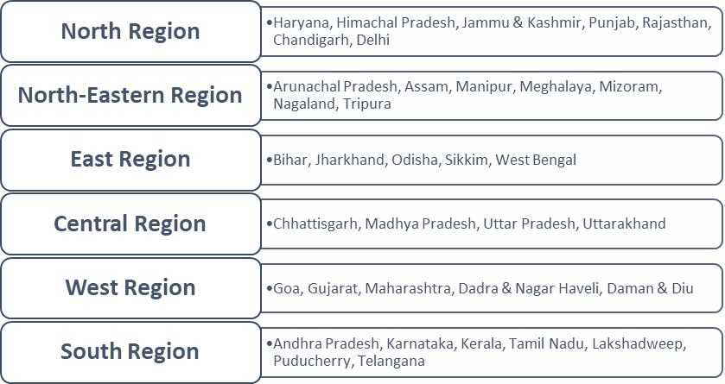

1. **Type of place of residence (Urban/Rural)**
2. **Highest Level of Education**
3. **Religion**
4. **Marital status**
5. **Respondent currently working**
6. **Respondent worked in last 12 months**
7. **Has money that respondent alone can decide how to use**
8. **Usually allowed to go to the market**
9. **Usually allowed to go to the health facility**
10. **Usually allowed to go to places outside this village**
11. **Has bank or savings account that respondent uses**
12. **Has mobile phone that respondent uses**
13. **Owns a land alone or jointly**
14. **Has bank account that the respondent uses**
15. **Wealth Index**
16. **Visited a health facility or camp for self or children in last 3(or 12) months**
17. **Type of health facility or camp visited for self or children in last 3 months**
18. **Type of health facility: Public or Private**
19. **Experienced any less severe violence (D105A-C,J) by husband/partner**
20. **Experienced any severe violence (D105D-F) by husband/partner**
21. **Experienced any domestic violence by husband/partner.**

**The variables listed as 23 and 24 were combined and recoded into variable 25.**

Fig.1.2 Domestic Violence recoded to single category

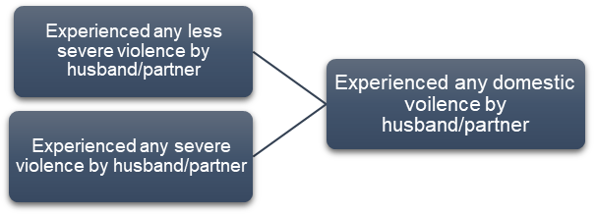

1. **Body Mass Index(BMI)**

Fig.1.3 Different Body Mass index categories recoded into three categories.

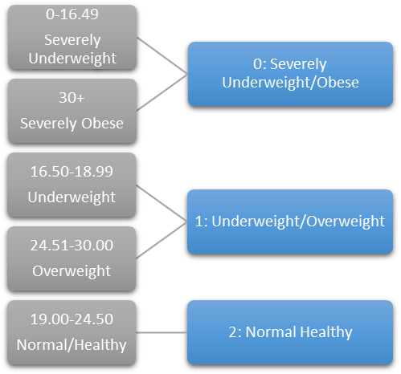

1. **Nutrition**

Fig.1.5 Different frequencies of consuming food items recoded under two categories.

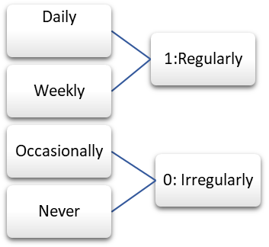

Fig.1.4 Different food items recoded into one category.

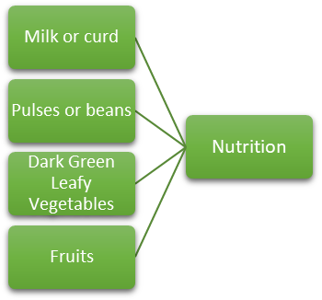

**Formulation of Women Empowerment Index**

* ***Knowledge***

The knowledge domain was computed as the aggregate of two categories, namely ‘Literacy level’ that had categories recoded as cannot read a sentence at all, Able to read only parts of a sentence, and Able to read the whole sentence. It was found that out of total interviewed women, 62.2% were able to read the whole sentence while 32.1% were not able to read any part of the sentence, and remaining 5.7% were able to read only a few parts of the sentence. The other category, which was taken under knowledge domain, was ‘Education level’, which had four levels, namely No education, Primary education, Secondary education, and Higher Education. It was found that 28.1% women had no education, 12.6% had completed primary education, 47.9% had completed secondary education and 11.4% of women had attained higher education. The third component included in the knowledge domain was ‘Employment Status’, in which the question was asked if the respondent had a job in last 12 months. It was found that only 4.1% women were having a job.

* ***Health & Hygiene***

The domain of health and hygiene has been calculated based on questions asked in the survey about women’s personal health seeking behavior and hygienic aspects. It was found that 20% of women had visited a health-care facility in 12 months. In order to evaluate the nutritional component of health and hygiene, we included questions asked about the health eating habits. The food group contained vegetables, fruits, milk or curd, pulses or beans and fried fruits. It was found that about 97% women had at least one of the food group item regularly (daily or weekly), while 3% of women had the items irregularly (occasionally or never).

* ***Decision making***

The survey asked a question from women; both employed and non-employed whether or not they have money that they can alone decide how to spend. It was found that 42% of women report having their own funds that they can independently determine how to utilize.

* ***Financial domain***

They survey inquired about women’s financial ownership. It was found 53% possess a bank or savings account that they personally utilize, while 46% have their own mobile phone. And about 49% of women own a land jointly with their husband/partner, while 28% of women own a land alone.

* ***Violence against women***

The surveys conducted by the National Family Health Survey (NFHS) inquire about women's personal encounters with physical and sexual violence. Based on the collected data, it was found that approximately 33% of ever-married women in India encountered instances of physical, emotional and/or sexual violence throughout the survey periods.

Fig.2.1. Domains of WEI

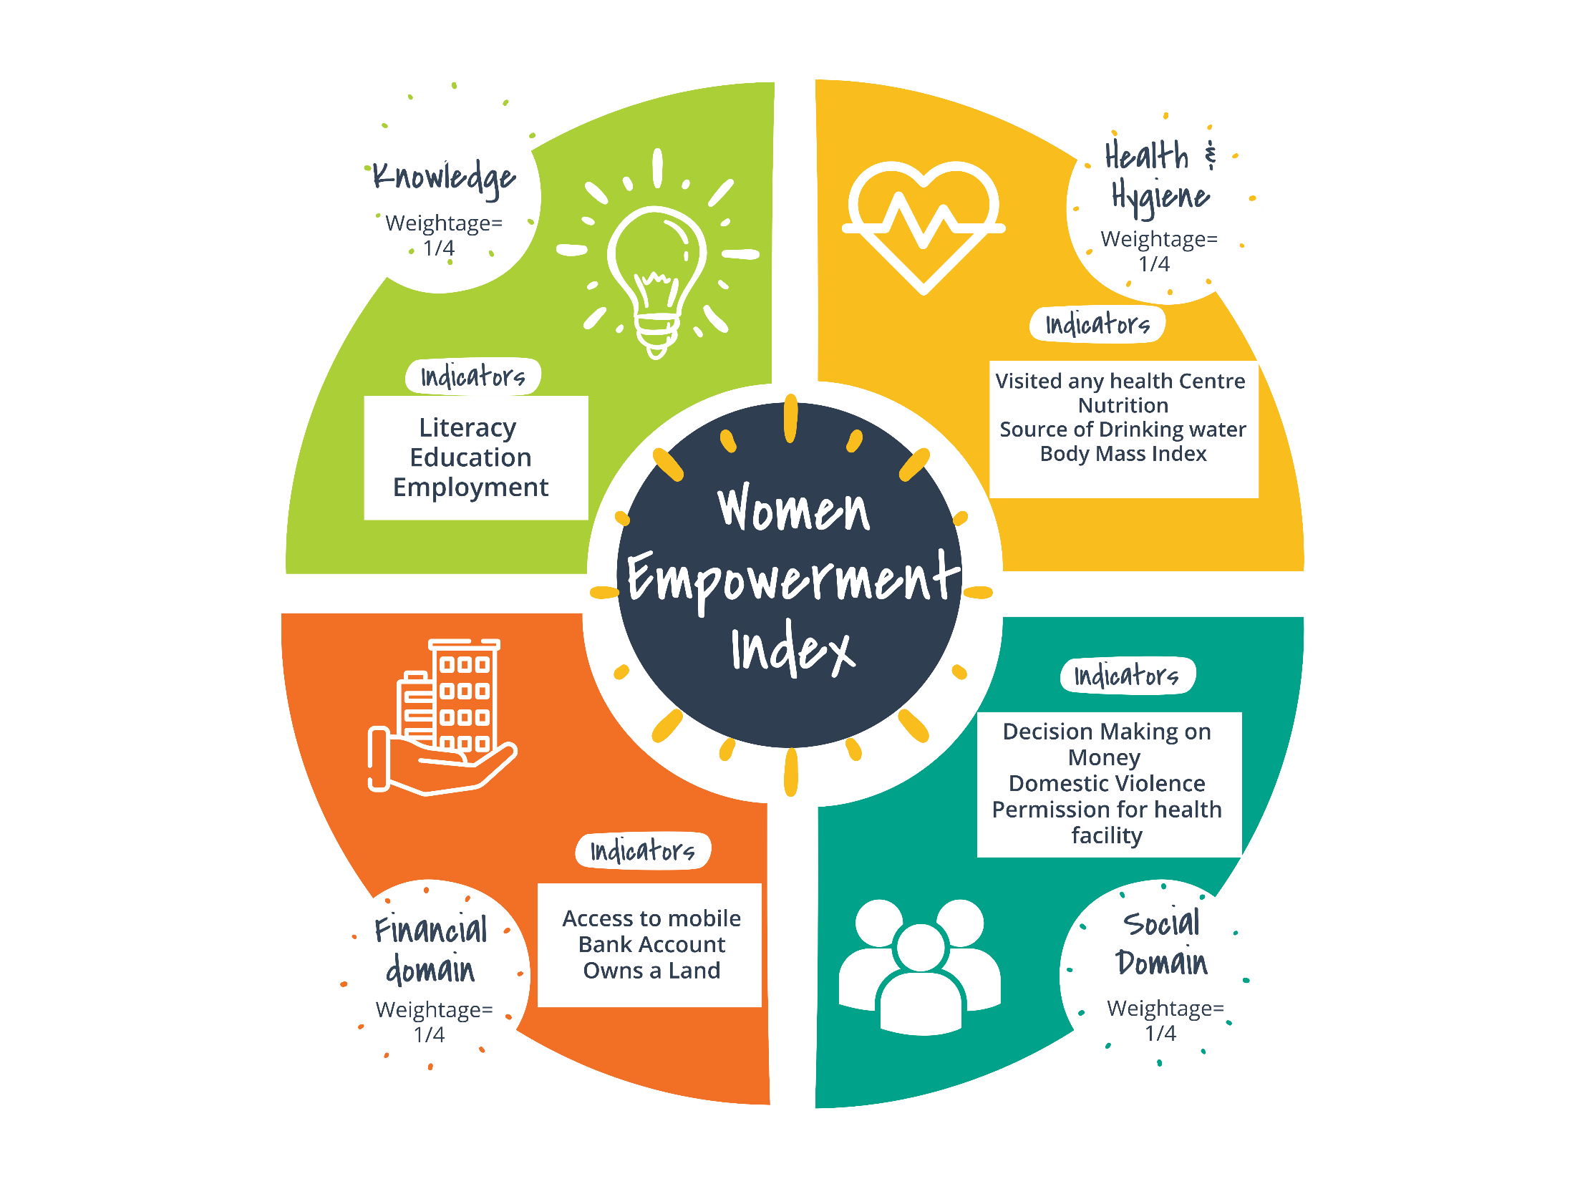

For formulation of Women Empowerment Index, we identified four major domains through we can evaluate an individual woman in every aspect. The four domains are- **Knowledge Domain**, **Health & Hygiene Domain**, **Social Domain**, and **Financial Domain**. After this, we identified 12 components that can be used as indicators of the major domains. Literacy level, Education level, and Employment were used as the indicators of Knowledge Domain. For Health & Hygiene Domain, Visited any health care centre in last 12 months, Nutrition practices, Source of drinking water, and Body Mass Index were used as indicators. Decision making on own money, Experience of domestic violence, and Permission to visit health facility were used as indicators for social domain. And for Financial Domain, the indicators used were Access to mobile phone, Access to bank account, Owns a property.

For assigning weightage to the domains and its indicators for the index value to have a range between 0 and 1, equal weightage were assigned to each domain i.e. ¼ to each domain, that would sum upto to 1 for the best case. Likewise, the indicators were given equal weightage in accordance with their size of cases.

Ultimately, the weightage given to indicators were used to formulate the index in such a way that the best case would have highest numeric value. So, rather than using the orthodox weightage method of calculating total scores obtained and multiplying by weightage of domain, instead we used **bottom to top method** of calculating the index by dividing the equal weightage within components with respect to their individual cases and summing upto to obtain the true value of index for the individual. This would give every answer to the question of indicator equal chance to contribute in the final value of the index.

|  |  |  |  |
| --- | --- | --- | --- |
| Component/Domain | Indicator | Weightage | Individual weightage of cases |
| Knowledge (K)  WK. = 1/4 | | | |
|  | 1. **Literacy(K1)**    * **0: Cannot Read at all**    * **1: Able to read parts of sentence**    * **2: Able to read whole sentence** | **WK1 = 1/12** | **1/24 (3 cases)** |
|  | 1. **Education(K2)**    * **0: No Education**    * **1: Primary**    * **2: Secondary**    * **3: Higher** | **WK2 = 1/12** | **1/36 (4 cases)** |
|  | 1. **Employment(K3)**    * + **0: No**      + **1:Yes** | **WK3 = 1/12** | **1/12 (2 cases)** |
| Health and Hygiene (H)  WH. = 1/4 | | | |
|  | 1. **Visited any medical facility(H1) in last 3/12 months**    * **0: No**    * **1: Yes** | **WH1 = 1/16** | **1/16 (2 cases)** |
|  | 1. **Nutrition(H2)**    * + **0: Irregular**      + **1: Regular** | **WH2 = 1/16** | **1/16 (2 cases)** |
|  | 1. **Source of drinking water(H3)**     * + **0: Unimproved Drinking water**      + **1: Improved Drinking water** | **WH3 = 1/16** | **1/16 (2 cases)** |
|  | 1. **BMI**    * + **0: Severely Underweight/Obese**      + **1: Thin/Overweight**      + **2: Normal/Healthy** | **WH4 = 1/16** | **1/32(3 cases)** |
| Social Domain(S)  WS. = 1/4 | | | |
|  | 1. **Has money that respondent alone can decide how to use (S1)**    * + **0: No**      + **1: Yes** | **WS1 = 1/12** | **1/12 (2 cases)** |
|  | 1. **Domestic Violence(S2)**    1. **0: Yes**    2. **1: No** | **WS2 = 1/12** | **1/12 (2 cases)** |
|  | 1. **Getting Permission to visit health facility(S3)**    * + **0: Big problem**      + **1: Not a big problem**      + **2: No Problem** | **WS3 = 1/12** | **1/24 (3 cases)** |
| Financial Domain(F)  WF. = 1/4 | | | |
|  | 1. **Access to Mobile(F1)**  * **0: No** * **1: Yes** | **WF1 = 1/12** | **1/12 (2 cases)** |
|  | 1. **Bank account (F2)**  * **0: No** * **1: Yes** | **WF2 = 1/12** | **1/12 (2 cases)** |
|  | 1. **Owns a land/house (F3)**    * + - **0: Does not own**        - **1: Alone only**        - **2: Jointly**        - **3: Both alone and jointly** | **WF3 = 1/12** | **1/36 (4 cases)** |

**Statistical Analysis & Results:**

Descriptive statistics of WEI:

Sample size = 699685

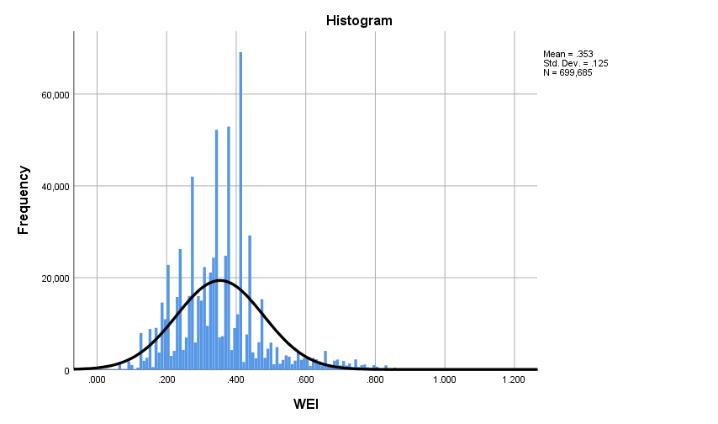

Fig.3.2 Histogram of WEI

Fig.3.1 Descriptive statistics of WEI

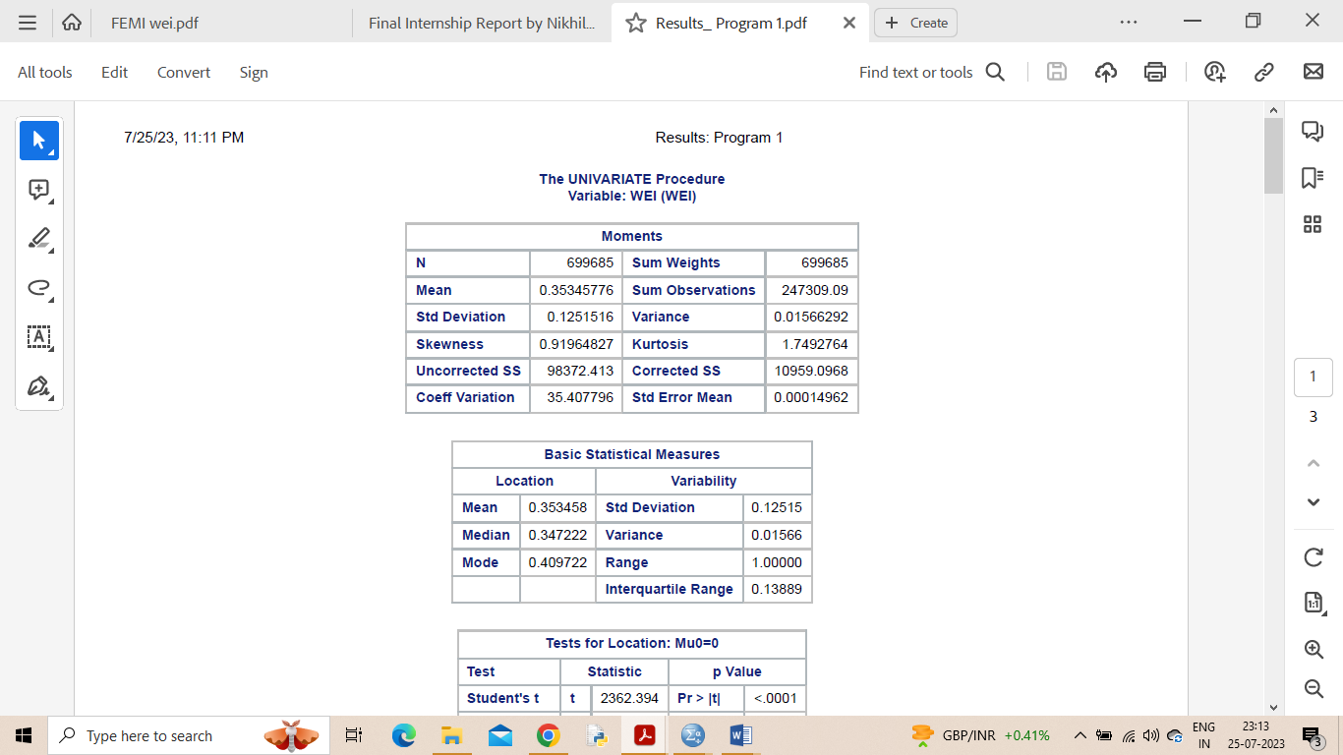

* **Check for Normality of WEI**:

**Kolmogrov-Smirnov test for Normality:**

H0 : Given Data comes from a normal distribution.

                  Vs

H1 : Given data comes from statistically significantly different from a normal distribution.

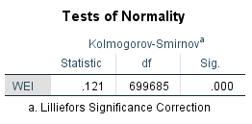

Test statistic: 0.121

P value: 0.000

Conclusion: The data comes from different distribution other than normal

x

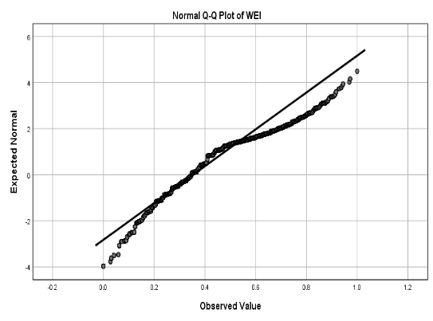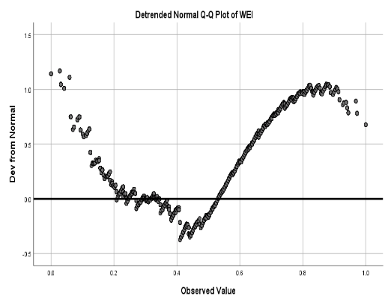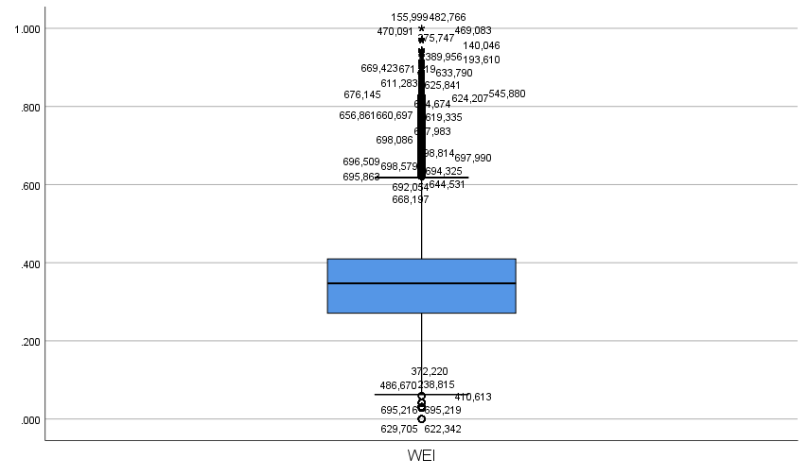

Fig.3.3 QQ plot and Box plot to check normality of WEI

Since the data of WEI does not follow normal distribution, so we have to use **non-parametric tests** for further statistical analysis.

* We also divided WEI in to three category for easier comparison of WEI with different influencing factors. **Low: 0.0 to 0.3**, **Moderate: 0.3 to 0.7, High: 0.7 to 1.00.**

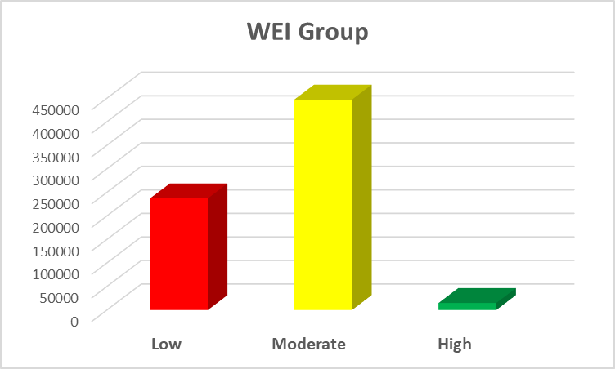

Fig.3.4 Column chart of three groups of WEI

|  |  |  |
| --- | --- | --- |
| **WEI Group** | | |
|  | Frequency | Percent |
| Low | 237309 | 33.9 |
| Moderate | 447351 | 63.9 |
| High | 15026 | 2.1 |
| Total | 699686 | 100.0 |

* **Correlations of different domains with WEI**

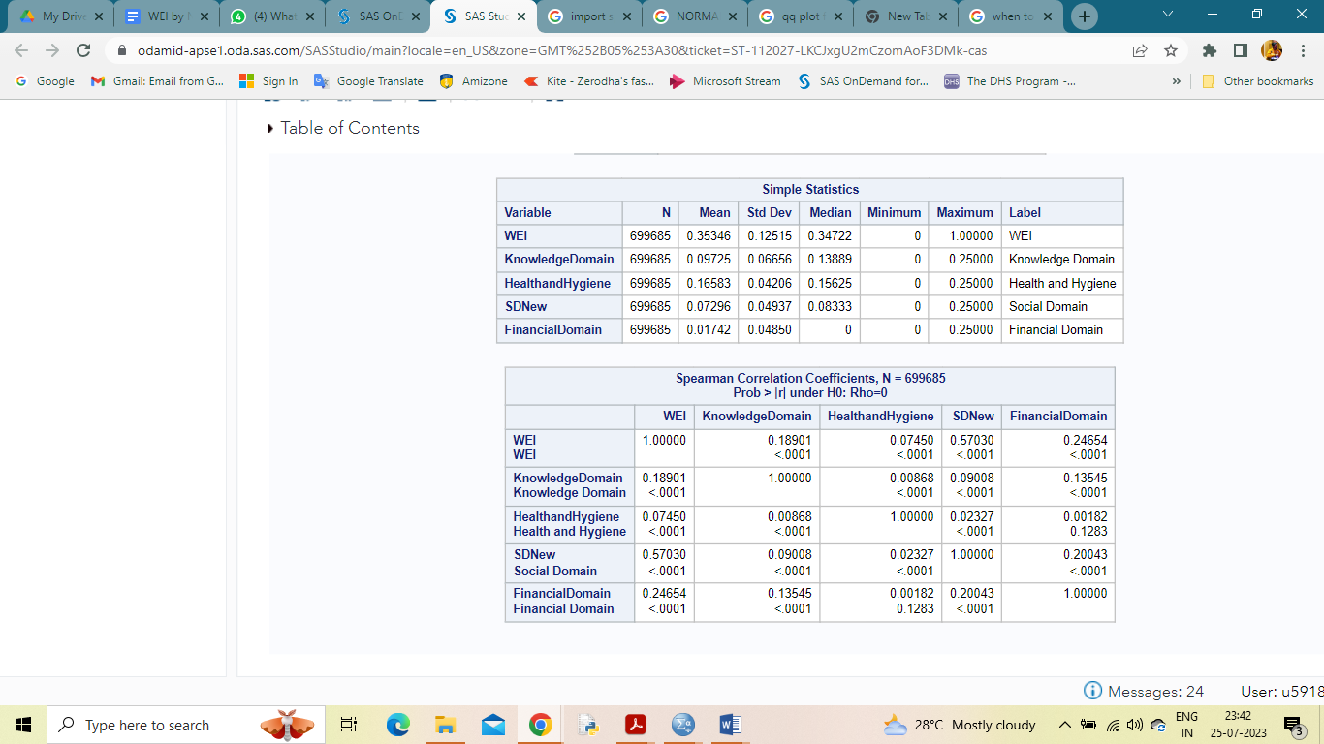

Fig.3.5 Spearman’s correlation matrix of WEI and different domains

As stated earlier that the data does not follow normal distribution, so we used spearman’s correlation to find out degree of linear relationship between WEI and different domains. Social Domain accounted for more degree of relationship that means about 57% of the WEI data can be explained by the social aspects of the individual.

**Analysis of WEI with respect to various socio economic characteristics:**

* **State wise distribution of WEI**

Fig.4.1.1 Heat map of India for WEI

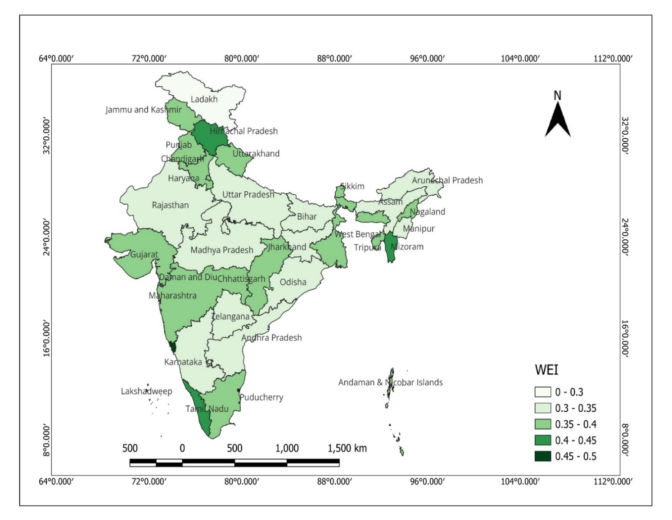

Fig.4.1.2 Bar diagram for states and UTs for WEI

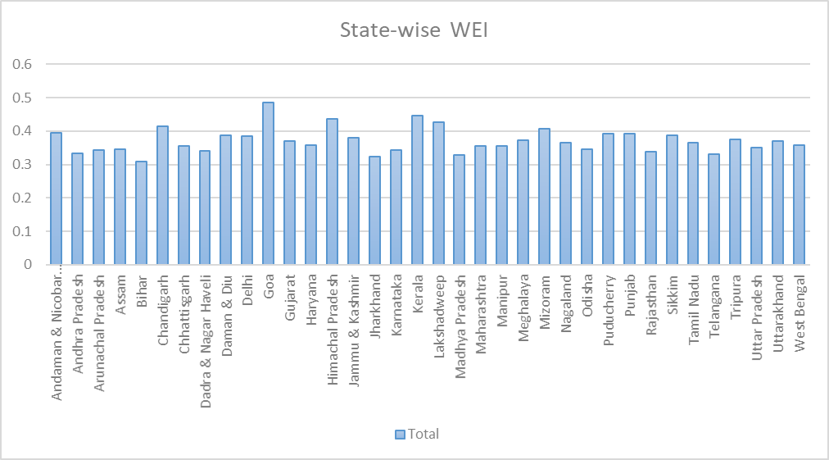

From the graphs, we can observe that Goa(0.48) has highest value of WEI followed by Kerala(0.45). Whereas, the states with lowest value of WEI are Jharkhand(0.32) and Bihar(0.30).

Fig.4.1.4 Region wise bar-diagram for mean WEI

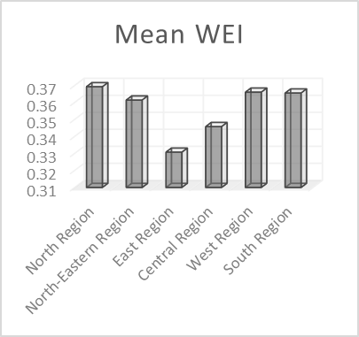

Fig.4.1.3 Region-wise descriptives of India for WEI



* **Influence of Marital status**

**Mann-Whitney U Test** for difference between Married and Not in Union groups for WEI values.

H0 : No difference between the samples.

                  Vs

H1 : Significant difference between the samples.



Fig.4.2.1 Mann-Whitney U Test Rank & Test Statistics for Marital status and WEI

**P-value is 0.882 (>0.05) supports the null hypothesis. Hence, we have insignificant evidence to reject the null hypothesis. Therefore, we can say that the two groups are similar.**

* **Educational impact**
  + **Kruskal-Wallis Test for independence of two or more samples**

**H0 : No difference between the samples.**

**Vs**

**H1 : Significant difference between the samples.**



Fig.4.3.1 Kruskal-Wallis H Test Rank & Test Statistics for Literacy level and WEI



**P-value is 0.00 (<0.05) supports the alternate hypothesis. Hence, we have significant evidence to reject the null hypothesis. Therefore, we can say that the groups are not similar.**

Table.2.1Cross-tabulation for Literacy and WEI groups

|  |  |  |  |  |  |
| --- | --- | --- | --- | --- | --- |
|  |  | WEI Group | | |  |
|  | **Categories** | **Low** | **Moderate** | **High** | **Total** |
| **Literacy** | Cannot Read at all | 41.4% | 27.5% | 20.8% | 32.1% |
| Able to read parts of a sentence | 6.2% | 5.5% | 4.8% | 5.7% |
| Able to read whole sentence | 52.4% | 67.0% | 74.4% | 62.2% |
|  |  | 33.9% | 63.9% | 2.1% | 100.0% |

Fig.4.3.2 Cluster charts for Literacy level and WEI

From the column graph for WEI according to Individual’s Literacy, we can observe that there is less number of women with High WEI when they have low level of literacy i.e. “Cannot read at all”. However, we get high value of WEI when the individual has high level of literacy(Able to read whole sentence).

* **Education**

**Chi-square test of independence of different categorical variables**

**H0: The variables are independent**

**H1: At least one of the variable(s) is dependent upon another variable(s).**

Fig.4.4.1 Chi-square test statistics table for Education and WEI

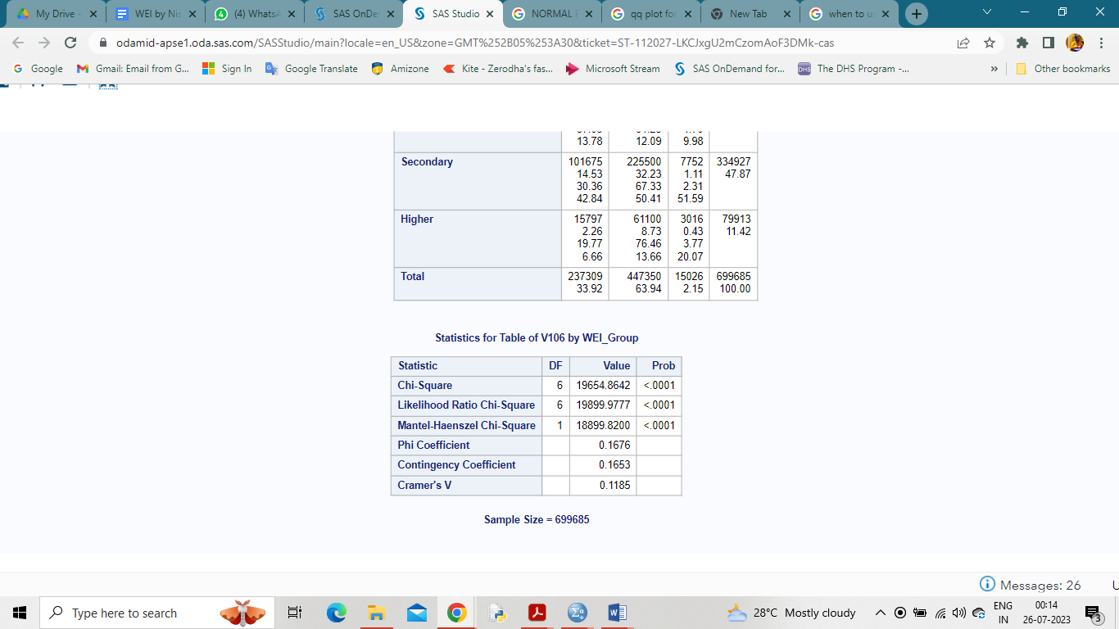

**So, we reject the null hypothesis and we conclude that the variables are not independent of each other.**

Table.2.2.Crosstabulation for Education and WEI groups

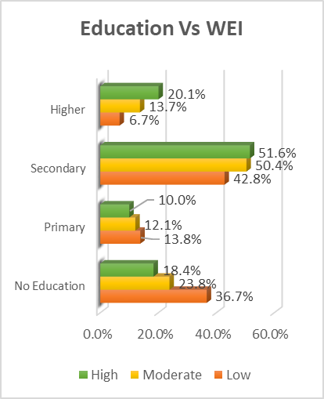

Fig.4.4.2 Cluster bar for Education and WEI

|  |  |  |  |  |  |
| --- | --- | --- | --- | --- | --- |
|  |  | ***WEI*** ***Group*** | | |  |
|  |  | Low | Moderate | High | Total |
| ***Education*** | No Education | 36.7% | 23.8% | 18.4% | 28.1% |
| Primary | 13.8% | 12.1% | 10.0% | 12.6% |
| Secondary | 42.8% | 50.4% | 51.6% | 47.9% |
| Higher | 6.7% | 13.7% | 20.1% | 11.4% |
|  | Total | 33.9% | 63.9% | 2.1% | 100.0% |

* **Type of place of residence (Rural or Urban)**
* **Chi square test for independence of categorical variables**
  + **H0 : Variables are independent**

**Vs**

* + **H1: Variables are significantly related.**

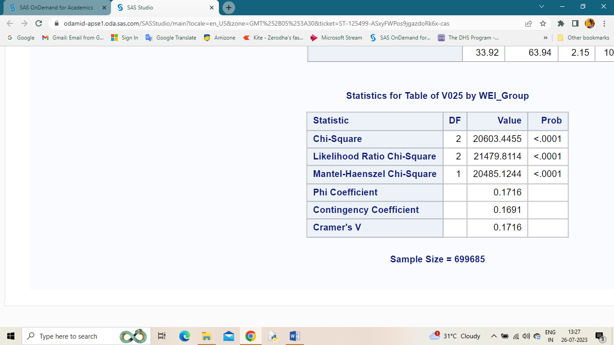

Fig.4.5.1 Chi-square test statistics table for Type of place of residence and WEI

Test statistic: 20603.445 (2 degrees of freedom)

P value: 0.000

**P value is significant, so we reject null hypothesis**

Table.2.3.Crosstabulation for Type of place of residence and WEI groups

|  |  |  |  |  |  |
| --- | --- | --- | --- | --- | --- |
|  |  | ***WEI Group*** | | |  |
|  |  | Low | Moderate | High | Total |
| ***Type of place of residence*** | Urban | 18.6% | 34.4% | 45.7% | 29.3% |
| Rural | 81.4% | 65.6% | 54.3% | 70.7% |
|  | Total | 33.9% | 63.9% | 2.1% | 100.0% |

Fig.4.5.2 Cluster bar and line chart for Type of education and WEI

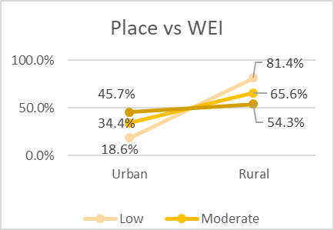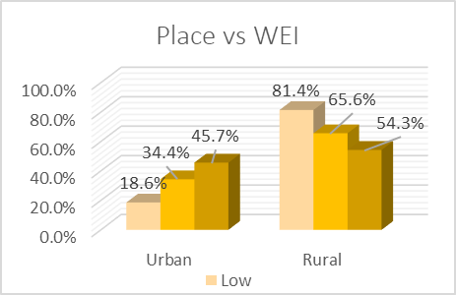

From the graph, we observe that there is high percentage of Low WEI in rural areas while a declining percentage can be observed for high WEI in rural areas. It is opposite in Urban areas. In urban areas, there is a high percentage of women with High WEI and low percentage of women with low WEI in. Hence, we can conclude that women living having their place of residence in urban areas are more likely to be empowered as compared to the ones living in rural areas.

* **Impact of Wealth Index on WEI**

Fig.4.6.1 Cluster bar and line chart for Wealth Index and WEI

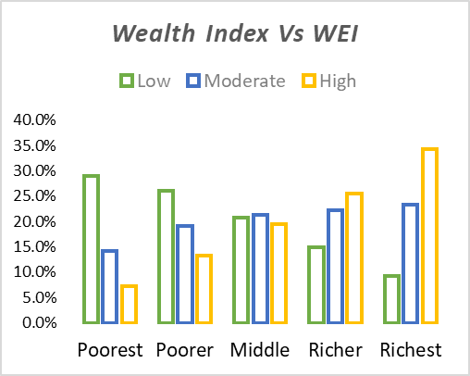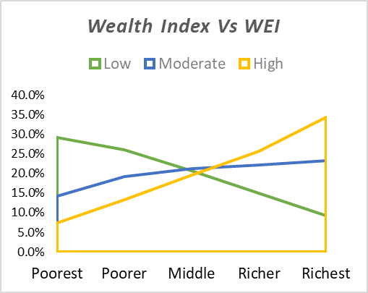

We can observe that Poorer the value in wealth index more are the percentages of Low WEI. While richer the value in the Wealth Index, more are the percentages of High WEI. We can also observe the slight increase in the “Moderate WEI” when we look from poorest to richest value in the wealth index.

* **Employment**

Fig.4.7.1 Tree diagram for Type of place of residence Employment and WEI

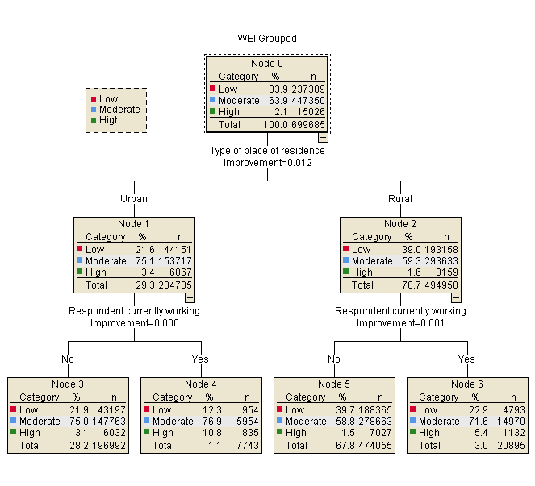

Table.2.4.Cross-tabulation for Employment & WEI

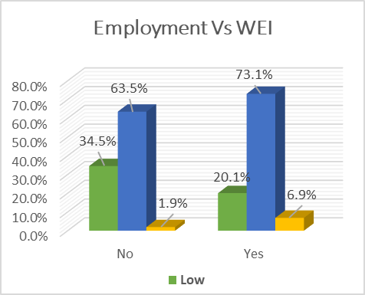

Fig.4.7.2 Cluster bar for Employment and WEI

|  |  |  |  |  |
| --- | --- | --- | --- | --- |
|  |  | WEI Group | | |
|  | Categories | Low | Moderate | High |
| Employment | No | 34.5% | 63.5% | 1.9% |
| Yes | 20.1% | 73.1% | 6.9% |

From the graph, we can conclude that there is certainly as aspect of empowerment, which is influenced by employment as we can observe that the percentages of WEI increases from non-employed women to employed women.

**Discussions & Conclusion**

There are many different possible definitions of empowerment, and it is not entirely clear which definitions to use and how to measure them. In addition, limitations in data availability have led to sub-optimal measurements of empowerment. According to WEI formulated, all the four domains viz knowledge, health & hygiene, social domain, and financial domain have a major impact on the empowerment index of a woman. From the data, considering the knowledge aspect of woman in todays India, we can find many developments in all the areas. The impact of “Beti Bachao Beti Padhao” yojna has been creating fruitful growth in the numbers of girls attending school. In education level, we found that most of the respondents have completed their secondary education. Literacy levels also showed positive percentage among woman individuals. In Health & Hygiene domain, we saw very less number of respondents visiting any type health care center. The number of employed individuals in rural area were more as compare to urban area.

In conclusion, the computed measure of index have an average of 0.35, showing a very low value of women empowerment in India. However, with lower levels of violence, and higher levels of health, education, decision-making, and gainful employment for women across India can result in improvement the index scale. While the WEI is attractive as it provides a single number, it is interesting to consider trends in individual categories and domains and how they contribute to changes in the WEI. There are many different possible definitions of empowerment, and it is not entirely clear which definitions to use and how to measure them. In addition, limitations in data availability have led to sub-optimal measurements of empowerment. We implemented the FEMI with data from India and the approach used could easily be extended to other countries as well. This would allow for country-to-country comparison as well as within-the-country comparison and study of variation.

Table.3.Socio-Economic characteristics of women as per NNFHS-4 data

|  |  |  |
| --- | --- | --- |
| Category | Frequency | Percent |
| Age Group | | |
| 15-19 | 124878 | 17.8 |
| 20-24 | 122955 | 17.6 |
| 25-29 | 115076 | 16.4 |
| 30-34 | 97048 | 13.9 |
| 35-39 | 90433 | 12.9 |
| 40-44 | 76627 | 11.0 |
| 45-49 | 72668 | 10.4 |
|  | 699685 | 100.0 |
| Residence | | |
| Urban | 204735 | 29.3 |
| Rural | 494950 | 70.7 |
|  | 699685 | 100.0 |
| Literacy | | |
| Cannot read at all | 224554 | 32.1 |
| Can read parts of sentence | 39783 | 5.7 |
| Able to read whole sentence | 435348 | 62.2 |
|  | 699685 | 100.0 |
| Education Level | | |
| No education | 196555 | 28.1 |
| Primary | 88290 | 12.6 |
| Secondary | 334927 | 47.9 |
| Higher | 79913 | 11.4 |
|  | 699685 | 100.0 |
| Marital Status | | |
| Married | 499626 | 71.4 |
| Not in Union(Never married, Divorced, Separated, Widowed) | 200059 | 28.6 |
|  | 699685 | 100.0 |
| Religion | | |
| Hindu | 519281 | 74.2 |
| Muslim | 94591 | 13.5 |
| Christian | 52112 | 7.4 |
| Sikh | 15300 | 2.2 |
| Buddhist | 8981 | 1.3 |
| Jain | 1028 | 0.2 |
| Others | 8392 | 1.2 |
|  | 699685 | 100.0 |
| State Region-wise |  |  |
| North | 123492 | 17.6 |
| North East | 93409 | 13.4 |
| East | 131540 | 18.8 |
| Central | 202936 | 29.0 |
| West | 56277 | 8.0 |
| South | 92031 | 13.2 |
|  | 699685 | 100.0 |
| Wealth Index | | |
| Poorest | 133249 | 19.0 |
| Poorer | 149466 | 21.4 |
| Middle | 147167 | 21.0 |
| Richer | 138502 | 19.8 |
| Richest | 131301 | 18.8 |
|  | 699685 | 100.0 |
| Employment | | |
| Working | 28638 | 4.1 |
| Not Working | 671047 | 95.9 |
|  | 699685 | 100.0 |

**Figures**

Fig.5.2 Pie chart for Rural-Urban

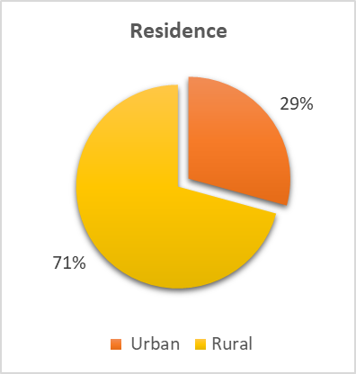

Fig.5.1 Column chart for Age in 5-year groups

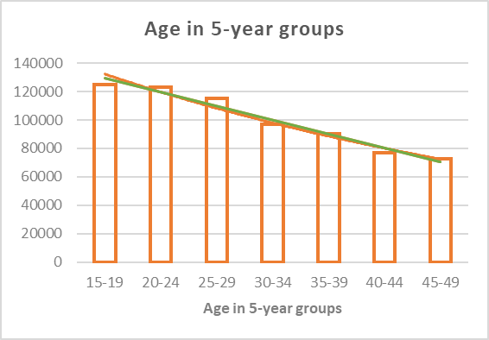

Fig.5.4 Pie chart for Education level

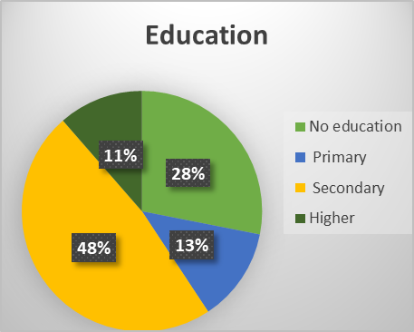

Fig.5.3 Column chart for Literacy level

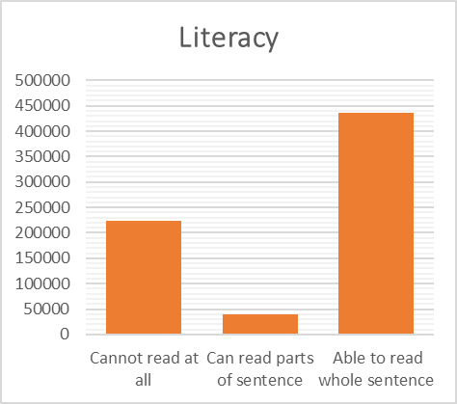

Fig.5.5 Pie chart for Religion

Fig.5.6 Pie chart for Marital Status

Fig.5.7. Column chart for States region-wise

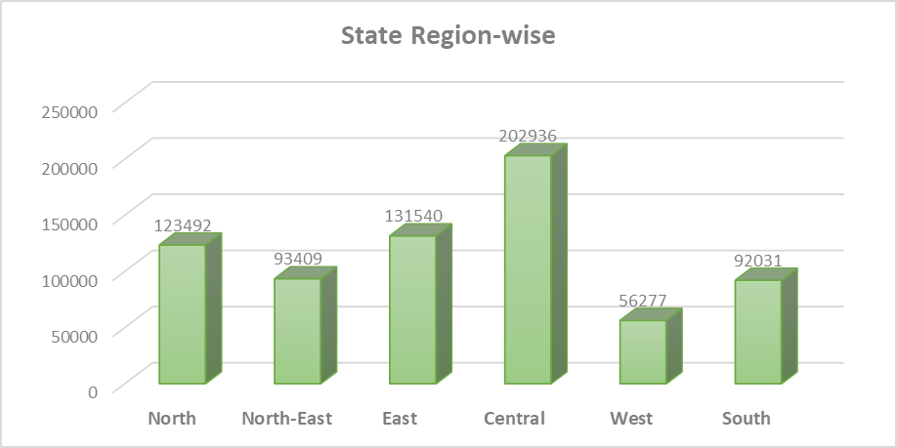

Fig.5.8. Pie chart for Employment

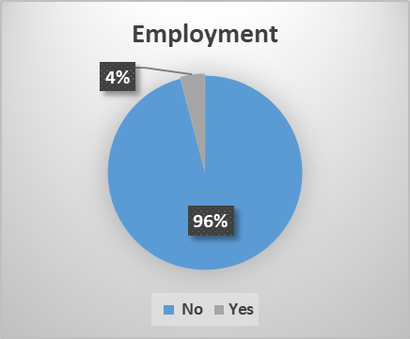

Fig.5.9. Column chart for Wealth Index

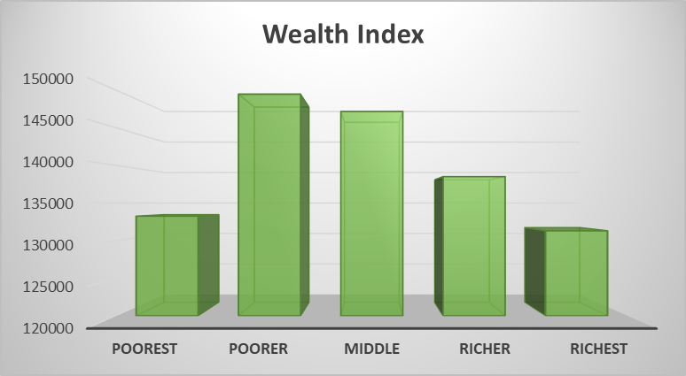

**References**

1. International Institute for Population Sciences (IIPS) and ICF. 2017.National Family Health Survey (NFHS-4), 2015-16: India. Mumbai: IIPS. Available from: http://rchiips.org/nfhs/NFHS-4Reports/India.pdf.
2. Ramesh H PAtil. “The Social Status of Indian Women of Different Periods in the Patriarchal Society”, An International Multidisciplinary e-Journal, vol. 5, núm. 4, pp. 1-10, 2021Welfare Universe. Available from: <https://www.redalyc.org/journal/7039/703973410005/html/>.
3. Anjana Jadon & Sadhana Shrivastava. Women Education in India: An Analysis. Availbale from: <https://core.ac.uk/download/pdf/234676365.pdf>.
4. Singh, P. and Pattanaik, F. (2019), "Economic status of women in India: paradox of paid–unpaid work and poverty", International Journal of Social Economics, Vol. 46 No. 3, pp. 410-428. Available from: <https://doi.org/10.1108/IJSE-05-2018-0277>.
5. UNDP (UnitedNation Development Programme).2016.HumanDevelopmentReport2016. Available from: <https://hdr.undp.org/system/files/documents//2016humandevelopmentreportpdf1pdf.pdf>